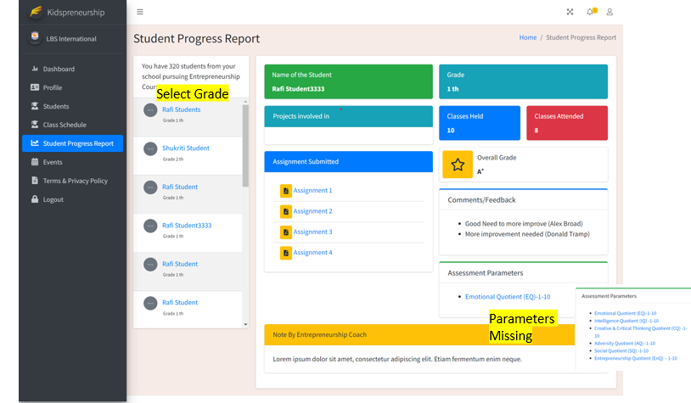

In red mark, what is parameters missing? Please describe.

I have mentioned 6 parameters against which assessment will be done. However in the design, I could only see one parameter - Emotional Quotient